SQL Server Integration Services

# Module 02 – Lab 01: Exercise 01: INstalling & Configure SQL Server Data Tools (SSDT)

1. If you have SSDT already installed skip to Exercise 02.
2. Launch Visual Studio 2019.
3. Click on “Continue without code”

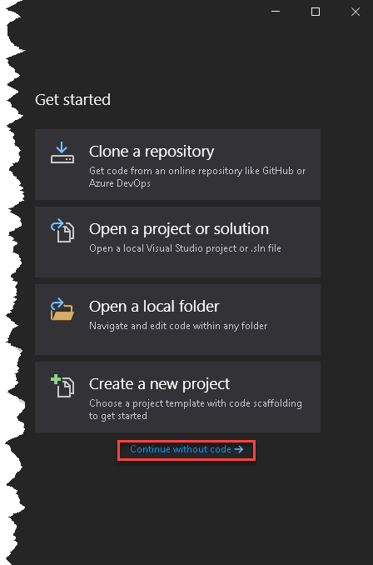

1. In Visual Studio, go to Extensions > Manage Extensions.
2. Under Search, look for “Integration Services” and click on “Download” for “SQL Server Integration Services”.
3. Follow the steps in the installation wizard and complete the steps. Restart if required.

# Module 02 – Lab 01: Exercise 02: Getting to know ssdt

1. Launch Visual Studio 2019.
2. In the Start Page, click “Create a new project”.  
   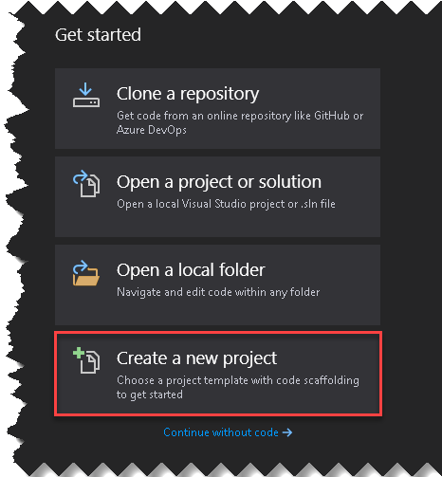
3. In the “Create a new project” dialog box, search for “Integration Services”. Select “Integration Service Project” and click Next.

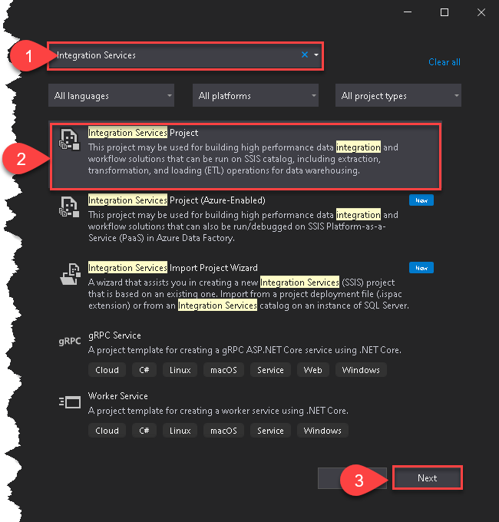

1. Next Define a name and location where to save the project. Click Create to start working in Visual Studio.

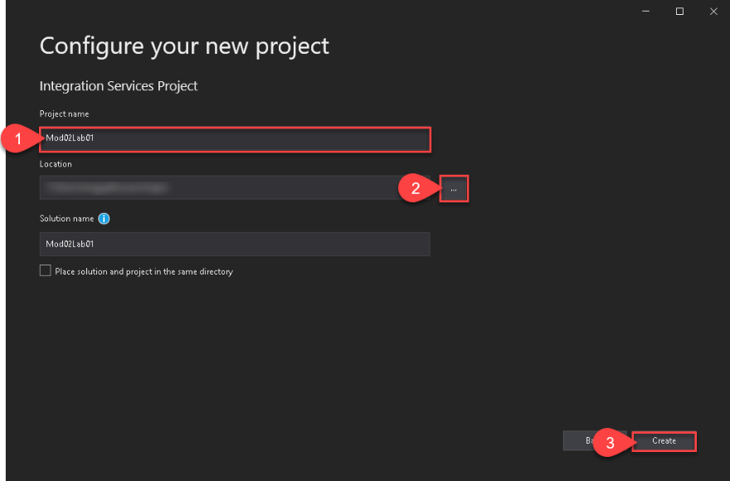

1. In the designer explore various options available to you:
   1. SSIS Toolbox (Left). Experiment with dragging and dropping few tasks on the designer window. Drop data flow task to explore the tasks inside data flow. Double-click tasks dropped to look at their respective properties. Can you explain why these tasks are marked with the alert?  
      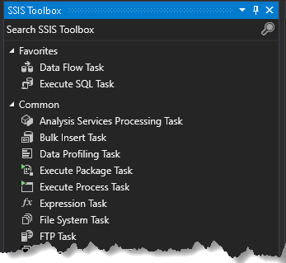
   2. Designer (Center Top). Review each of the tabs. Create tasks in Control Flow and Data Flow, review changes in Package Explore.   
      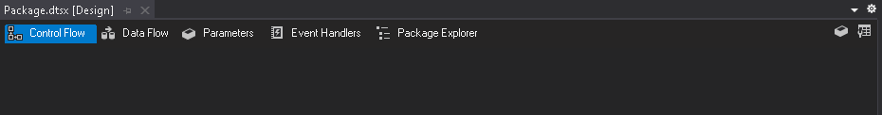
   3. Connection Manager (Center Bottom). Create a connection in package and create a connection in Project; what is the difference?



* 1. Solution Explorer (Right). Look at properties of the project, see if you change the deployment context.  
     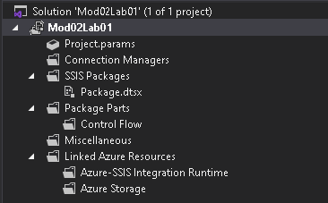
  2. In Package Explorer, explore various folders. What does each folder mean?

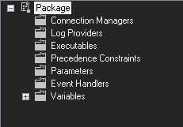

* 1. SSIS Menu is your one stop shop for all the SSIS package development functionality. Located under Extensions > SSIS. Also accessible by right clicking in the designer.  
     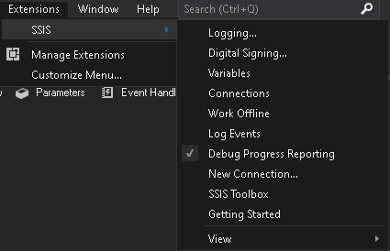

1. After exploring, build a simple package and execute it. Start by cleaning the designer by deleting all the tasks that might exist.
2. Then dropping a “Execute SQL Task” under SSIS Toolbox under Favorites on to designer.  
   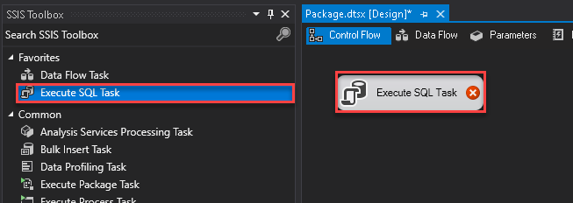
3. After the task is added to the design canvas, notice there is a white “x” in a red circle. This is an indication; we need to do configuration on the task. Double-click on the task. Click on the drop down by Connections and select <New connections…>.  
   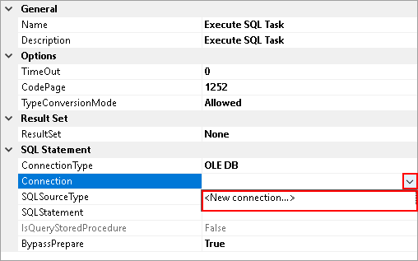
4. In Configure OLE DB Connect Manager, click New.  
   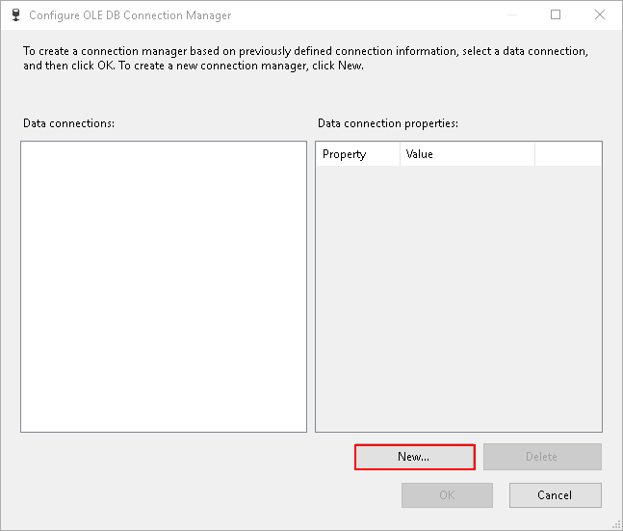
5. In connection manager, type the server’s name, select the database “AdventureWorks” and click OK.  
   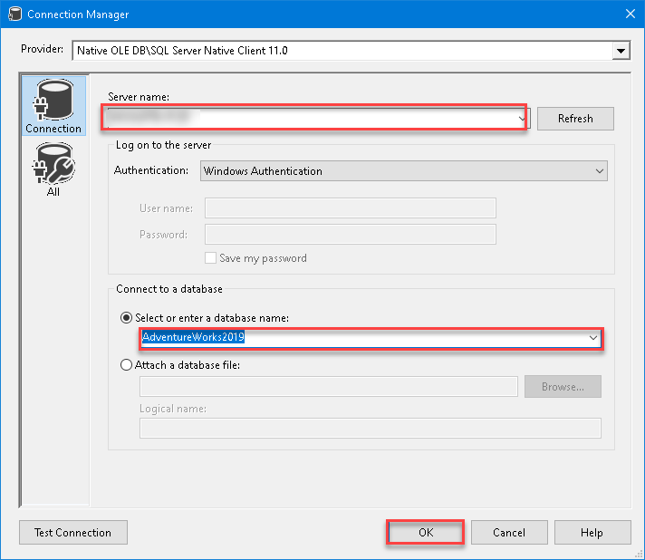
6. Click OK in Configure OLE DB Connection Manager.
7. Next click on SQLStatement and click on the ellipse beside it.  
   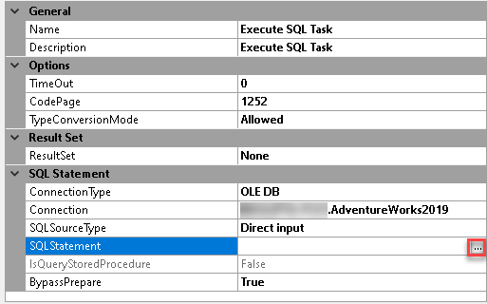
8. Type in following select statement and click OK.  
   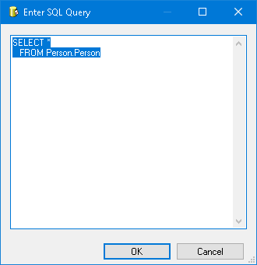
9. Click OK in the Execute SQL Task Editor, notice the alert is gone.
10. Click on “Start” or Press F5 to execute the package. Once executed properly it should return with green checkbox and you’ll have a new tab called progress. Click on it.  
    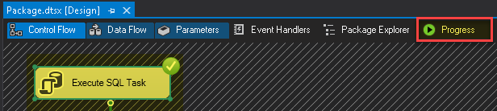
11. Review the output of the progress, to understand how long the task took to complete. This can be helpful in understand where the time is being spent in larger and more complex packages.  
    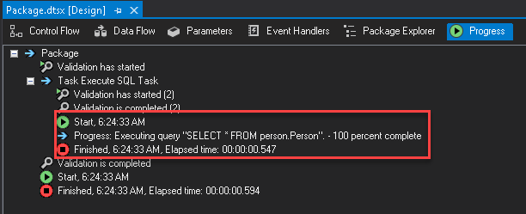
12. Click on “Stop”, Red Square button on the tool to stop.
13. Exit visual studio saving the project.